|  |
| --- |
| Stella Labs |
| Sirius Business |
| **Nova Sirius** |
| Version 6  All work Copyright © 2017 by Stella Labs.  All rights reserved. |
| **Shahidraja Raj 300748357**  **Bhaskar Sharma 300918010** |
|  |

|  |
| --- |
| January 3rd 2018 |

Contents

**Version History** 3

**Game Overview** 4

**Game Play Mechanics** 4

**Camera** 4

**Controls** 4

**Interface Sketch** 4

**Menu and Screen Descriptions** 5

**Game World** 5

**Levels** 5

**Game Progression** 5

**Characters** 6

**Enemies** 6

**Weapons** 6

**Abilities** 7

**Script** 7

**Scoring** 7

**Story Index** 7

**Bonuses** 7

**Art** 7

**Future Features** 8

**Level 1** 8

**Level 2** 9

**Updates at Beta Submission** 9

Level 1 Updates 10

Level 2 Updates 10

**Beta Test Session Summary** 10

# **Version History**

* **Version 1.0.0 –** Initial concept and document
* **Version 2.0.0 –** Changed Controls, Scoring and Interface sketch. Added Art, Cheat Codes, and Bonuses
* **Version 3.0.0 –** First playable build, main character movement, background scroll effects
* **Version 4.0.0 –** Alpha, The enemies are introduced and work with movement along with player
* **Version 5.0.0 –** Beta, Complete game working with collision events
* **Version 6.0.0 –** Code Freeze, Update game play, Fix previous errors

# **Game Overview**

*You play as Nova Sirius, a living star who has been created by Stella labs for use in war. Sirius isn’t too fond of this idea so he’s hell bent on getting out. It is now your mission to take control of Sirius and fight your way out of multiple test chambers and see the light of day.*

# **Game Play Mechanics**

*Player dodges obstacles, breaks through barriers and destroys enemies using varying fire balls.*

# **Camera**

*Camera is a 2D side scrolling perspective*

# **Controls**

*Mouse for moving up and down. A, S, D for fireballs and F for rage mode*

# **Interface Sketch**

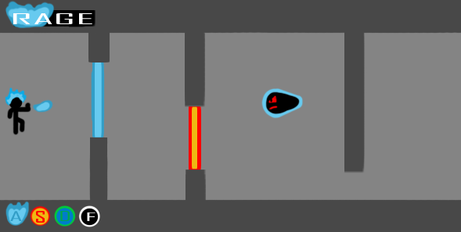

# **Menu and Screen Descriptions**

*Characters arms moves and selects options but pointing and lighting the words on fire*

# **Game World**

*Game takes place in a testing facility designed to create and train Nova’s powers*

# **Levels**

***First level:*** *Nova’s escapes. Enemies are introduced, if additional abilities are in the game then this is where they will appear.*

***Second Level/Boss Level:*** *The main boss is introduced and enemies are stronger and faster*

# **Game Progression**

*Player starts off with basic understanding of powers, as the game goes on they learn the powers as Nova Sirius does and escape the lab and try to score the highest in given time.*

# **Characters**

***Nova Sirius****: Able to create and manipulate fire of different types and change avatar accordingly*

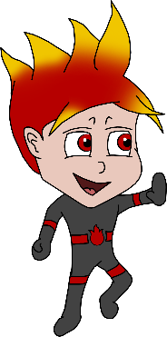

# **Enemies**

***Drones:*** *small security drones with barriers surrounding them that require fire to destroy*

***Black Star:*** *final boss. Appears in a giant mech suit that requires multiple fire types to destroy*

# **Weapons**

***Red fireballs:*** *standard high temperature fireballs*

***Blue fireballs:*** *standard high temperature fireballs*

***Green fireballs:*** *standard high temperature fireballs*

***Black fireballs:*** *Acidic fireballs*

# 

# **Abilities**

*Sirius has access to a rage ability that will cover him in white fire and will negate any fire type requirements for a temporary amount of time*

# **Script**

***Level 1:*** *Nova rebels and we see Black Star get angry**and kills all the black bots.*

***Level 2:*** *Nova discovers his abilities of changing body colors and gets even powerful and kills the boss eventually.*

# **Scoring**

*Destroying enemies will add varying values to rage and overall score in the unlimited mode*

# **Story Index**

*Stella Laboratories, that was working on human bodies, made many young guys sign contracts for the agreement for various experiments on their bodies. Problems happen when experiments on Nova Sirius go wrong that make him extra powerful than wanted. This leads to the uncovering of the head scientist's real evil plans. Nova finds out about this and tries to escape. The game revolves around Nova trying to escape the evil scientist's attacks while getting to understand his own special abilities and powers.*

# **Art**

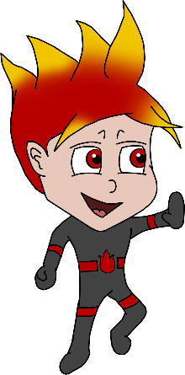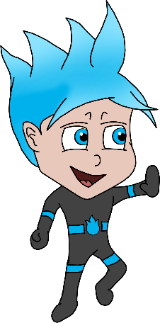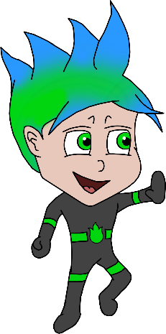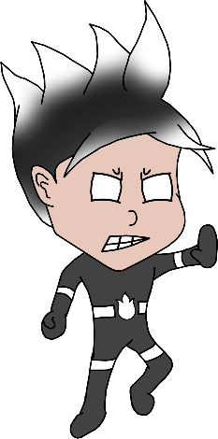

# **Future Features**

*May include more levels and characters in the future as well as more abilities and mechanics.*

# **Level 1**

Nova fights against three different enemies and tries to advances to next level

Keys for shooting bullets: **W**

Keys for movement: **Arrows** keys

**Level 1 background**:

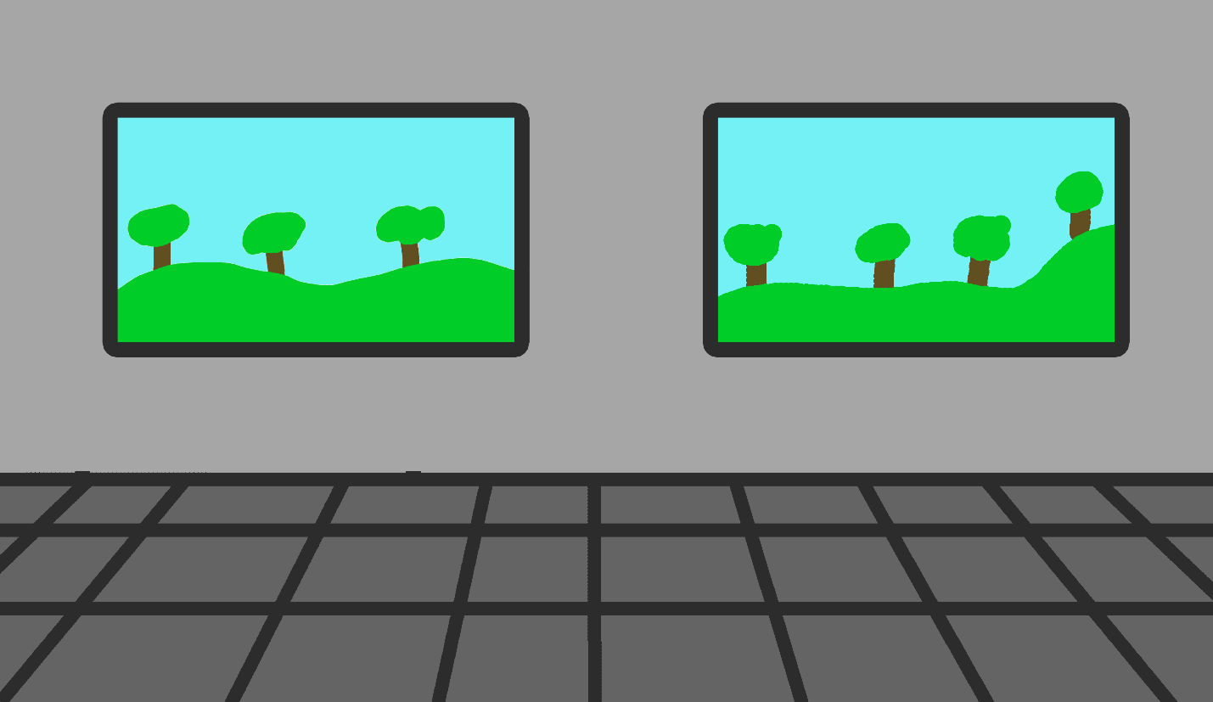

Nova costumes changes based on which bullets he is shooting. For example if he shoots red bullets his costumes will be red and similarly green for green and blue for blue

# **Level 2**

Sounds plays when nova shoots bullets

Nova can shoot different types of bullets with A,S and D and speed up in level 2

**Level 2 background:**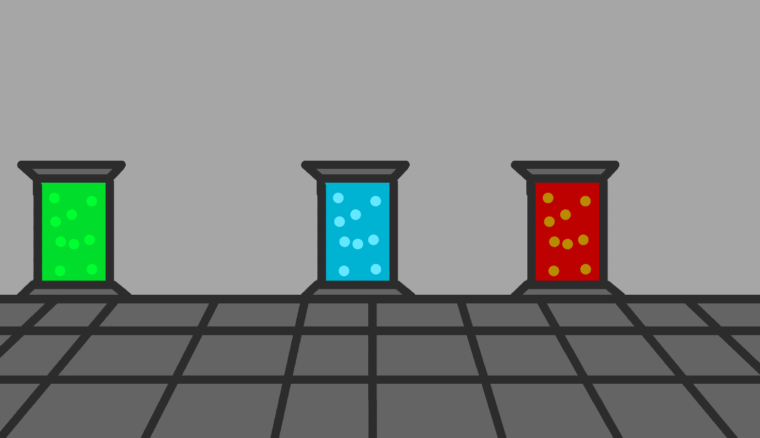

# **Enemies in Level 2**

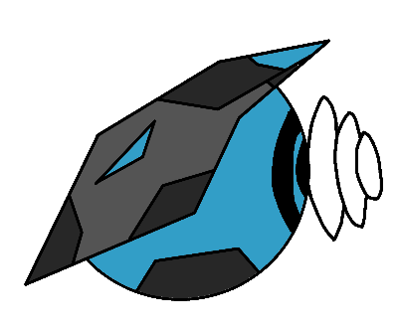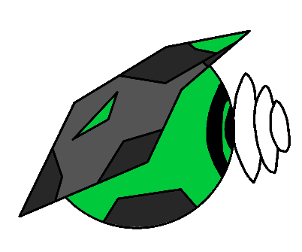 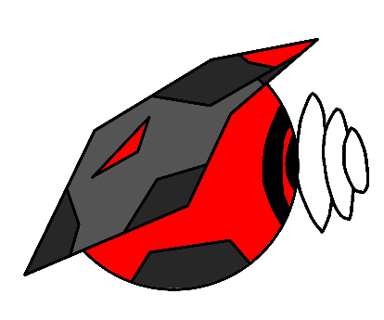

**Green Bots Blue Bots Red Bots**

**The Boss –**

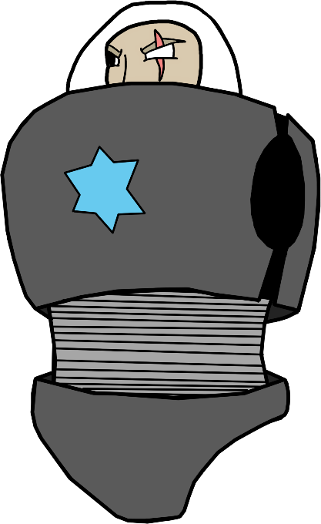

**Torso**

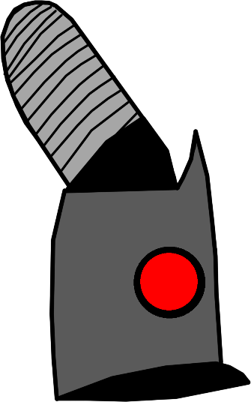 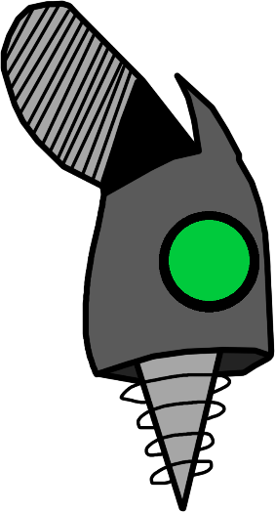

# **Leg Arm**

# **Updates at Beta Submission**

The both level works as indicated.

## Level 1 Updates

The Pause is added in the Level1.

Score and Time is added.

Main character is appeared and works as indicated

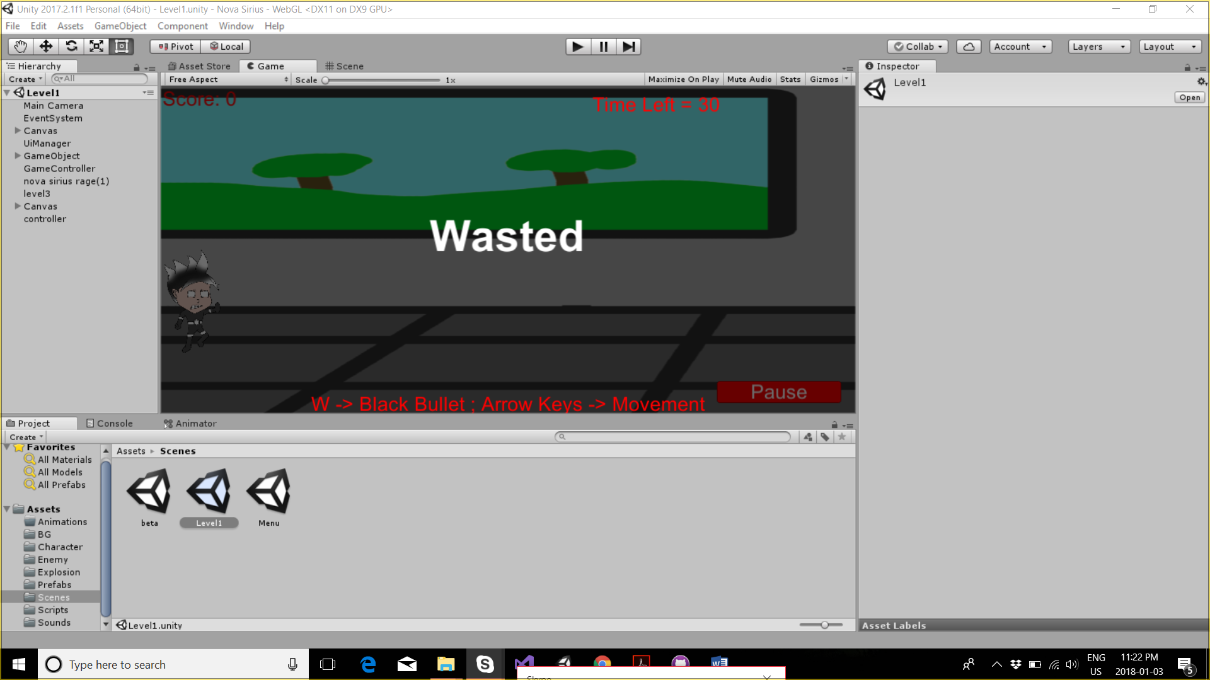

## Level 2 Updates

The boss appears after the enemy in the scene.

The boss is only destroyed after he is shot with color coordinated bullets. For instance, his arm is vulnerable to green bullets and in order to destroy his arm Nova must shoot him with green bullets and for the Torso its blue.

Once the boss is dead the game is over and Nova has completed his mission.

# 

# **Beta Test Session Summary**

Unfortunately, we were unable to test others game in the LAB and we couldn’t invite others to test us in the class. But we did book a learning session class and invited one of our class mate (Earl) to have his thought on our game.

Below is the updated after Earl tested our game:

* The Pause was not working which we fixed and made it work
* The transition from Level 1 to Level 2 is fixed
* The boss is destroyed with color matching bullets